Group A: Assignment No:03

Problem statement: A book consists of chapters, chapters consist of sections and sections consists of subsections. Construct a tree and print the nodes. Find the time and space requirements of your method.
#include<iostream>
#include<string.h>
using namespace std;
struct node
{
char label[10];
int ch_count;
struct node *child[10];
}*root;
class GT
{
public:
void create_tree();
void display(node* r1);

GT()
{
root = NULL;
}
};
void GT::create_tree()
{
int tbooks,tchapters,i,j,k;
root = new node;
cout<<"Enter the name of book:- "<<endl;
cin>>root->label;
cout<<"Enter no. of chapters in book:- "<<endl;
cin>>tchapters;
root->ch_count = tchapters;

for(i = 0; i<tchapters; i++)
{
root->child[i] = new node;
cout<<"Enter chapter name:- "<<endl;
cin>>root->child[i]->label;
cout<<"Enter no. of secions in Chapter "<<root->child[i]->label<<" :- ";
cin>>root->child[i]->ch_count;

for(j = 0; j<root->child[i]->ch_count; j++)
{
root->child[i]->child[j] = new node;
cout<<"Enter Section "<<j+1<<" name\n";
cin>>root->child[i]->child[j]->label;

cout<<"Enter the no. of subsections in "<<root->child[i]->child[j]->label<<":- ";
cin>>root->child[i]->child[j]->ch_count;

for(k = 0; k<root->child[i]->child[j]->ch_count; k++)
{
root->child[i]->child[j]->child[k] = new node;
cout<<"Enter subsection "<<k+1<<" name\n";
cin>>root->child[i]->child[j]->child[k]->label;
}

}
}
}
void GT::display(node *r1)
{
int i,j,k,tchapters;
if(r1!=NULL)
{
cout<<"\n------Book Hierarchy-------"<<endl;
tchapters = r1->ch_count;

cout<<"\n--------Chapter----------"<<endl;
for(i = 0; i<tchapters; i++)
{
cout<<"\n Chapter "<<i+1<<" "<<r1->child[i]->label;
cout<<"\nSections:-"<<endl;
for(j = 0; j<r1->child[i]->ch_count; j++)
{
cout<<r1->child[i]->child[j]->label;

cout<<"\nSub-Section:- "<<endl;

for(k = 0; k<r1->child[i]->child[j]->ch_count; k++)
{
cout<<r1->child[i]->child[j]->child[k]->label<<endl;
}
}
}
}
}
int main()
{
int choice;
GT gt;
while(1)
{
cout<<"-----------"<<endl;
cout<<"Book Tree Creation"<<endl;
cout<<"-------------"<<endl;
cout<<"1. Create"<<endl;
cout<<"2. Display"<<endl;
cout<<"3. Quit"<<endl;
cout<<"Enter your choice: ";
cin>>choice;

switch(choice)
{
case 1:
gt.create_tree();
case 2:
gt.display(root);
break;
case 3:
exit(1);
default:
cout<<"Wrong choice"<<endl;
}
}
return 0;
}

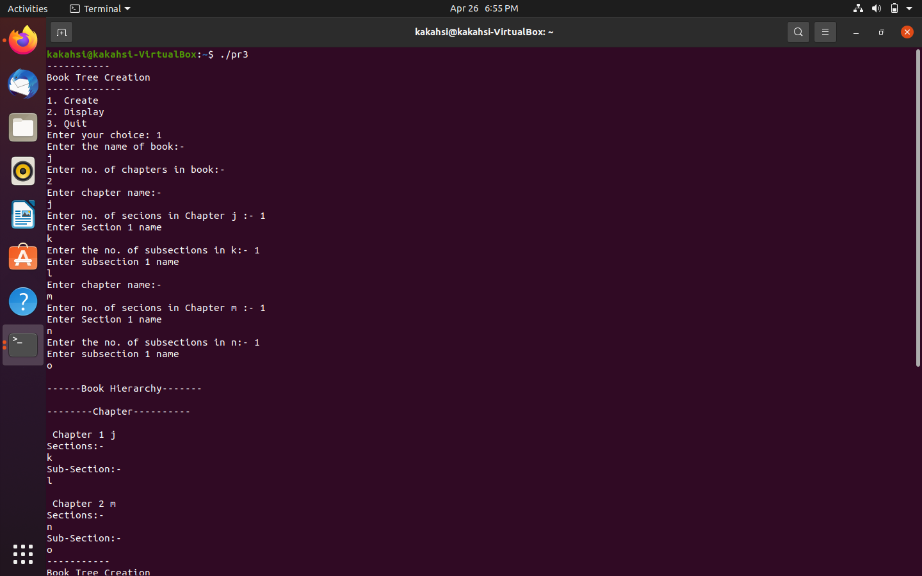
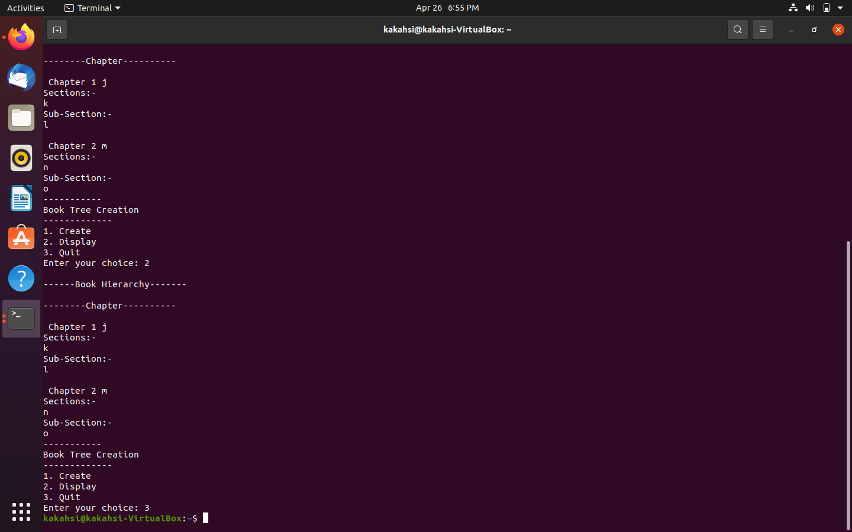
Output:

